实验2数组
一. 实验目的及实验环境
1学会一维数组的创建和使用，了解Java数组与C程序中数组的区别。
2理解数组赋值和数组内容复制的区别（浅复制与深复制）。
3熟练Java类库中的java.util.Arrays类，并能熟练运用。
4初步认识面向过程编程与面向对象编程的区别。
5 学会创建并应用对象数组。
6学会Eclipse调试工具的使用。

二. 实验内容
1 基本内容（实验前请及时熟悉如下相关内容）
1）一维数组的创建和使用
2）数组的赋值和数组内容复制
3）搜索数组的常用算法：线性查找、二分查找
4）数组元素排序的常用算法：选择排序、插入排序
5）Java类库中的java.util.Arrays类的常用方法

2 综合实验：
2.1 (朱晓龙2011年《Java语言程序设计》P183: 2) 编程完成一维数组的排序。

2.2(朱晓龙2011年《Java语言程序设计》P183: 7)设在数组a中存有10个整数，现从键盘输入一个数，检查该数是否在数组中，若在数组中，则输出该数在数组中的位置，若在数组中未找到该数，则输出“Not Found！”信息。

2.3 (Y. Daniel Liang英文版八版P232：6.19)(Sorting students) Write a program that prompts the user to enter the number ofstudents, the students’ names, and their scores, and prints student names indecreasing order of their scores.
（中文）梁勇2011年《Java语言程序设计-基础篇》第8版P184：6.19；

2.4(Y. Daniel Liang英文版八版P233：6.27Identical arrays) Two arrays list1 and list2 are identical if they have thesame contents. Write a method that returns true if list1 and list2 are identical,using the following header:
public static boolean equal(int[] list1, int[] list2)
Write a test program that prompts the user to enter two lists of integers and displayswhether the two are identical. Here are the sample runs. Note that the firstnumber in the input indicates the number of the elements in the list.
（中文）梁勇2011年《Java语言程序设计-基础篇》第8版P186： 6.27
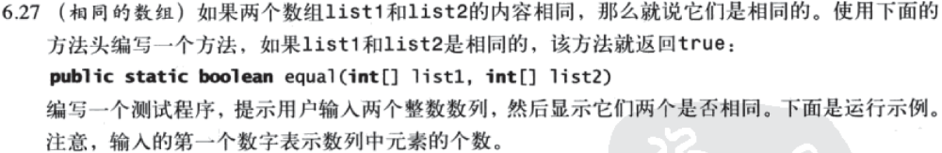
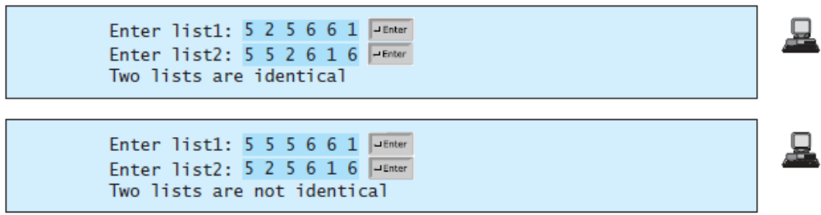

2.5附加题（供学有余力同学完成，平时成绩有加分！☻）
(Y. Daniel Liang英文版八版P367：10.7)**(Game: ATM machine) Use the Account class created in Exercise 8.7 to simulatean ATM machine. Create ten accounts in an array with id 0, 1, 9, and initialbalance $100. The system prompts the user to enter an id. If the id is enteredincorrectly, ask the user to enter a correct id. Once an id is accepted, the mainmenu is displayed as shown in the sample run. You can enter a choice 1 for viewingthe current balance, 2 for withdrawing money, 3 for depositing money, and 4for exiting the main menu. Once you exit, the system will prompt for an id again.So, once the system starts, it will not stop.
（中文）梁勇2011年《Java语言程序设计-基础篇》第8版P296： 10.7
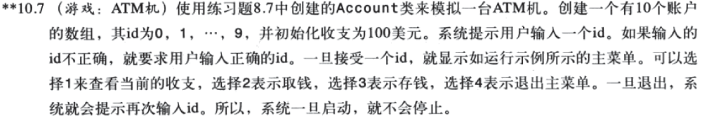
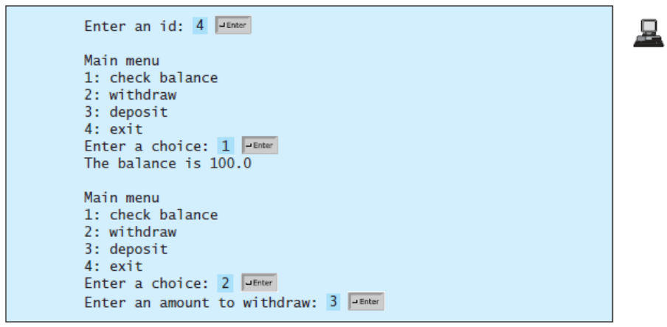

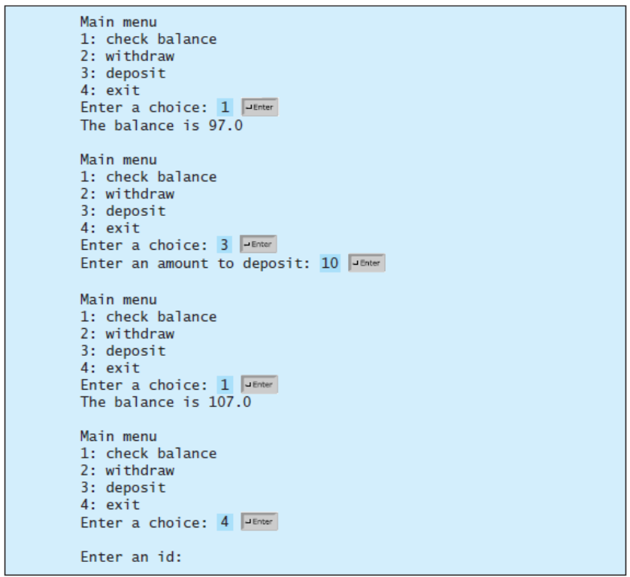

2.6附加题（供学有余力同学完成，平时成绩有加分！☻）
(Y. Daniel Liang英文版八版P371：10.14)
10.14* (The MyDate class) Design a class named MyDate. The class contains:
■ Data fields year, month, and day that represent a date.
■ A no-arg constructor that creates a MyDate object for the current date.
■ A constructor that constructs a MyDate object with a specified elapsed timesince midnight, Jan 1, 1970, in milliseconds.
■ A constructor that constructs a MyDate object with the specified year, month,and day.
■ Three get methods for the data fields year, month, and day, respectively.
■ A method named setDate(long elapsedTime) that sets a new date for theobject using the elapsed time.
Write a test program thatcreates two Date objects (using new Date() and new Date(34355555133101L))and display their hour, minute, and second.
(Hint: The first two constructors will extract year, month, and day from the elapsedtime. For example, if the elapsed time is 561555550000 milliseconds, the year is1987, the month is 10, and the day is 17. For the no-arg constructor, the currenttime can be obtained using System.currentTimeMills(), as shown in Listing2.6, ShowCurrentTime.java.)

（中文）梁勇2011年《Java语言程序设计-基础篇》第8版P300： 10.14
注意：不要求画出UML图。
